TOWN OF LEXINGTON
HOUSING REHABILITATION GRANTS
The Town of Lexington is considering applying for a
Community Development Block Grant (CDBG)
to fund the rehabilitation of homes for its residents
WE NEED YOUR HELP TO BUILD A WAITLIST!!!

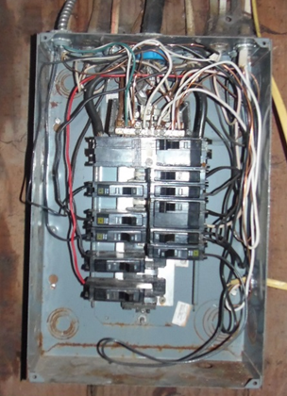
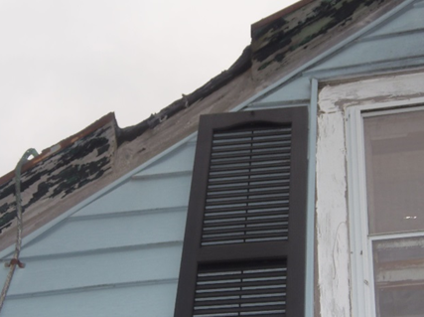
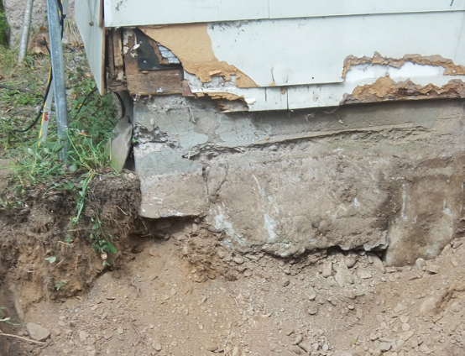

Are you a full-time resident in the Town of Lexington?
Do you have a stick-built home?
Do you need health and safety repairs on your home?
Call or email today to get on the waitlist

607-652-2823 ext. 102 or info@westerncatskills.org
www.westerncatskills.org/programs/

