Town of Lexington Town Board Meeting
June 2, 2020 Via Zoom
Supervisor JoEllen Schermerhorn opened the meeting at 6:05 PM followed by the Pledge of Allegiance to the American Flag. There was a moment of silence in memory of Warren Strausser

Present: Supervisor JoEllen Schermerhorn
Council Members Bradley Jenkins
Michael Barcone
William Pushman
Bennett Wine
Superintendent of Highways Frank Hermance
Town Clerk Charlotte Jaeger
Town Attorney Tal Rappleyea

Others Present: Jo Cross & Mike Ryan from the Mountain Eagle

RESOLUTION # 53-20
Accept May 5, 2020 Minutes
On a motion by Council Member Michael Barcone, seconded by Council Member William Pushman the following was,

ADOPTED: Ayes – 5 - Barcone, Jenkins, Pushman, Schermerhorn, & Wine
Nays -0

Therefore this Town Board accepts the minutes from the May 5, 2020 meeting as presented.

RESOLUTION # 54-20
Financial Reports for April
On a motion by Council Member Bradley Jenkins, seconded by Council Member Bennett Wine the following was,

ADOPTED: Ayes – 5 - Barcone, Jenkins, Pushman, Schermerhorn, & Wine
Nays -0

Therefore this Town Board moves to accept the financial reports through April 2020.

Highway Report
Superintendent of Highways Frank Hermance said that the Highway department should be finished with the boom mower on Friday. The emergency repairs on Timberlake road are done. He got his new pick up truck.
He will be closing Spruceton Road on June 9,10, & 11 for repairs 7:00 am to 3:30 pm. The Town part of Spruceton road from Wolffs bridge, not all of Spruceton Road. Council Member Bennett Wine was concerned about the hikers.
Auction Bids
The 2003 pick up truck bid came in at $1,600.00 and the 2004 truck bid came in at $12,200.00.

RESOLUTION # 55-20
Accept Bids
On a motion by Council Member William Pushman, seconded by Council Member Bradley Jenkins the following was,
ADOPTED: Ayes – 5 – Barcone, Jenkins, Pushman, Schermerhorn, & Wine
Nays - 0

Therefore this Town Board moves to accept the bid for the 2003 truck for $1,600.00 and the 2004 truck bid in the amount of $12,200.00.

Opening Plan
Supervisor Schermerhorn thanked Peggy Rappleyea and Jo Cross for their work on this.

RESOLUTION # 56-20
Municipal Building Reopening Plan
On a motion by Council Member Bennett Wine, seconded By Council Member Michael Barcone the following was,

ADOPTED: Ayes – 5 – Barcone, Jenkins, Pushman, Schermerhon, & Wine
Nays - 0

Therefore this Town Board moves to accept the Municipal Building Reopening Plan:
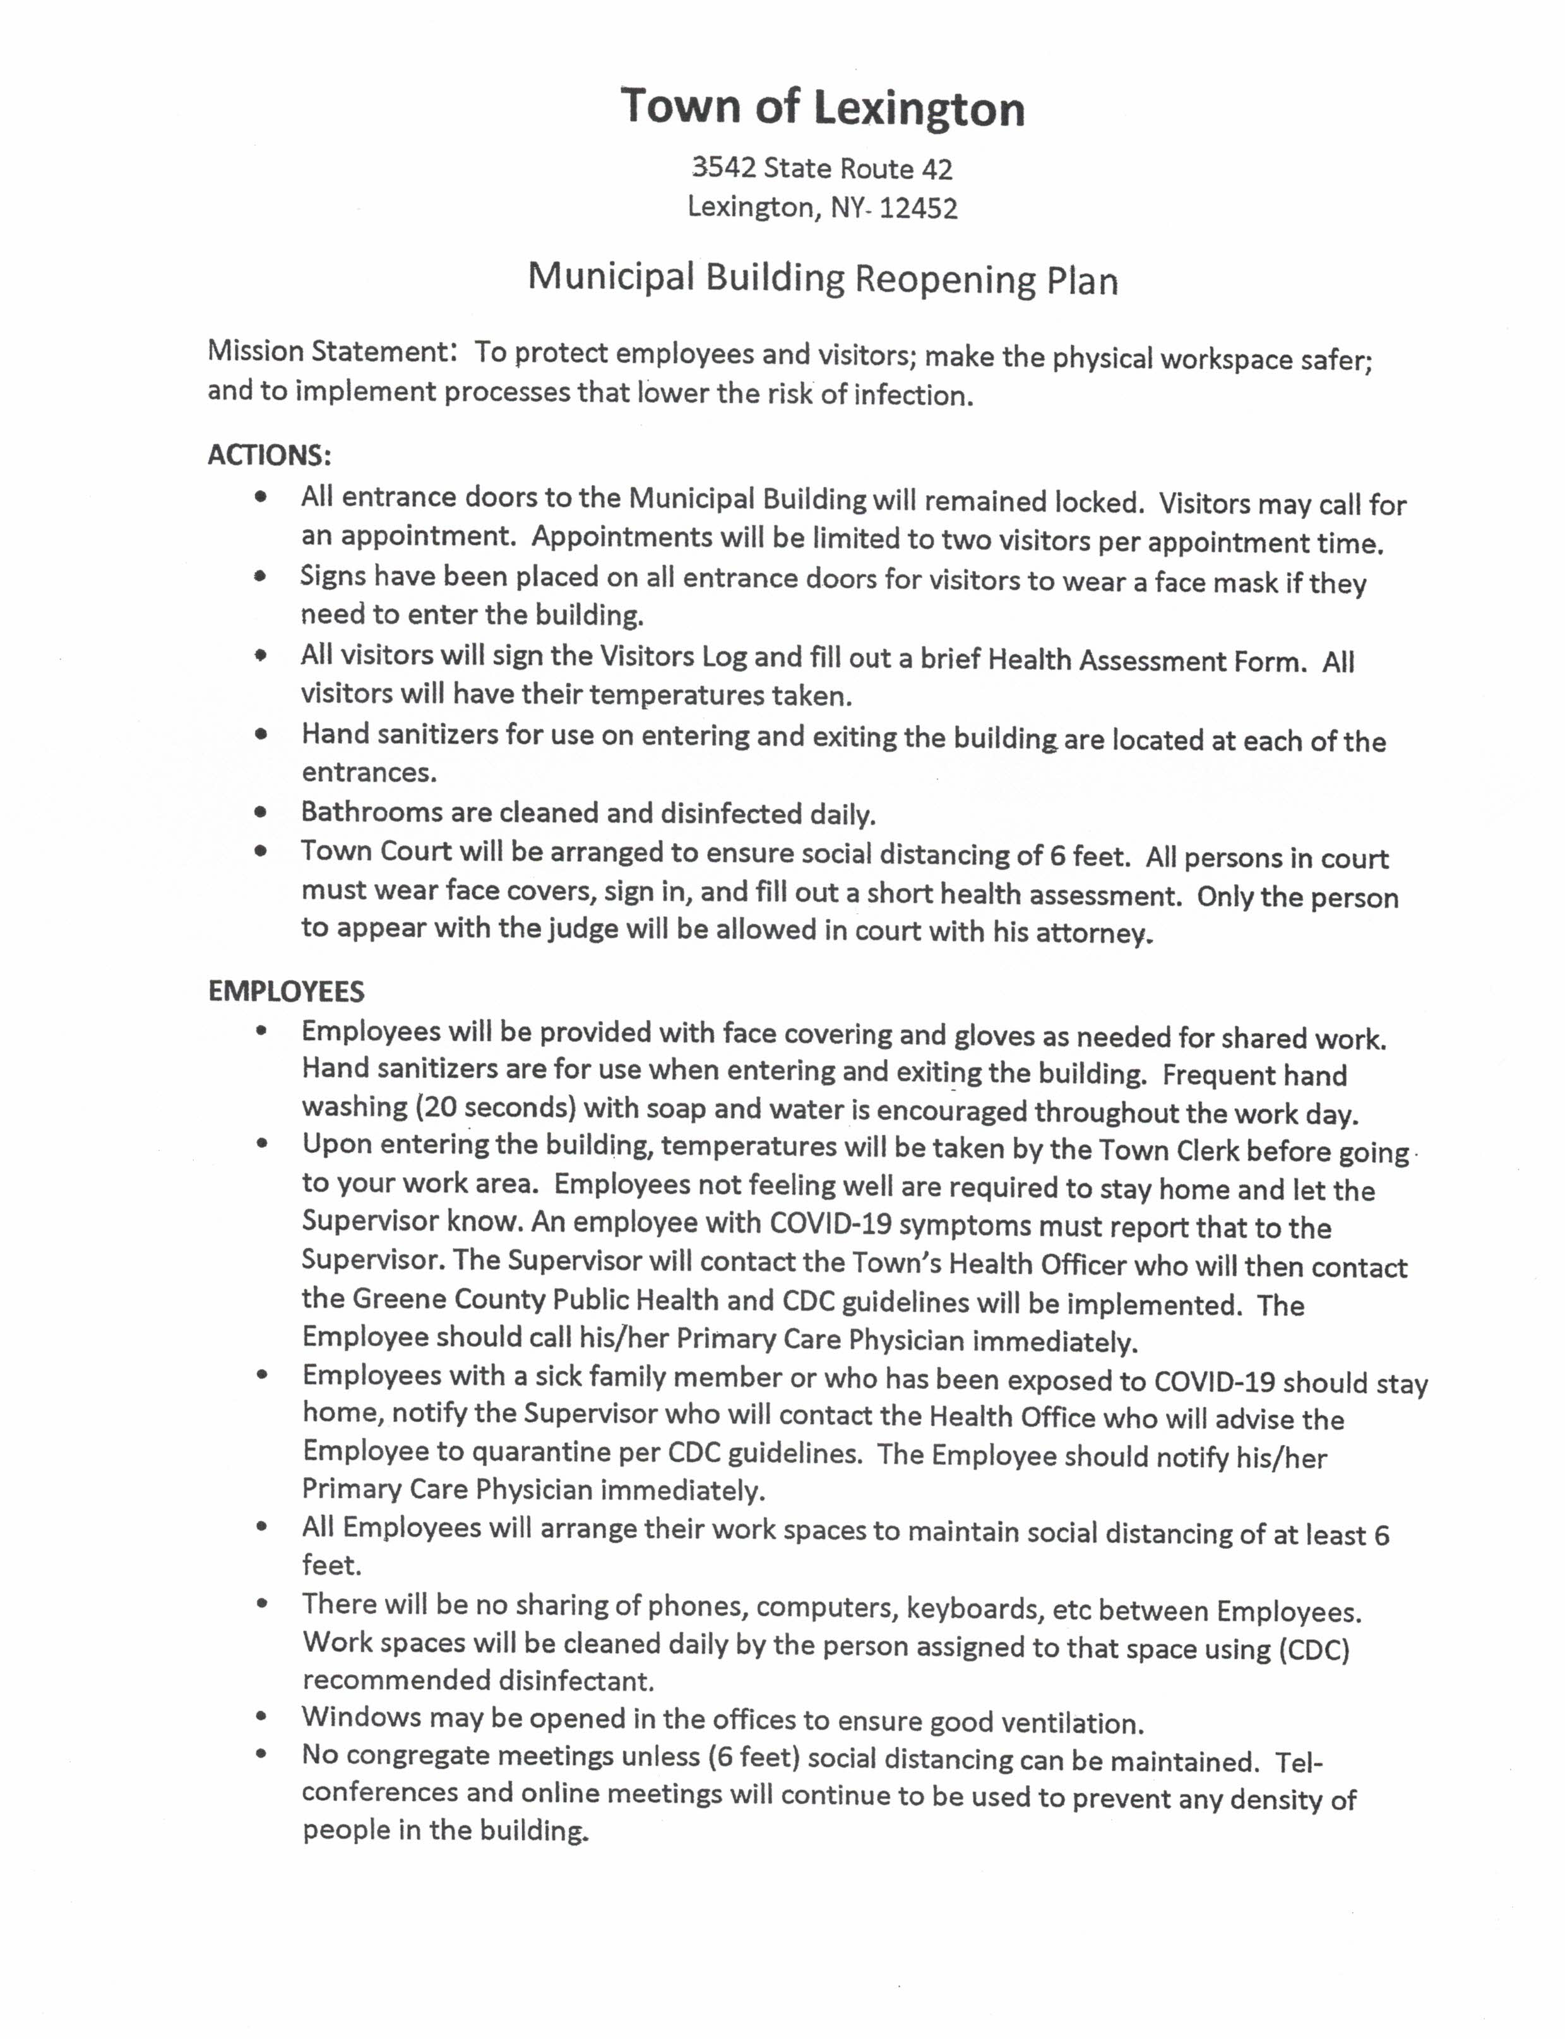
RESOLUTION # 57-20
Court Hours
On a motion by Council Member William Pushman, seconded by Council Member Michael Barcone the following was,
ADOPTED: Ayes – 5 – Barcone, Jenkins, Pushman, Schermerhorn, & Wine
Nays - 0

Therefore this Town Board moves to change the Lexington Court hours to the 1st Monday of the month at 6:00 PM and the 3rd Monday of the month at 10:00 am at the request of the Judges. This change will start in July. The Court opening is still pending as per the State.

RESOLUTION # 58-20
Transfer Money from ICS Account
On a motion by Council Member Michael Barcone, seconded by Council Member Bradley Jenkins the following was,

ADOPTED: Ayes – 5 – Barcone, Jenkins, Pushman, Schermerhorn, & Wine
Nays - 0

Therefore this Town Board moves to transfer $11,486.50 from the ICS account to the Highway account DA9950.9. This money is to pay for the new pick up truck. The red truck will be used as a fuel truck with limited miles.

Update

Covid-19 – Health Officer Jo Cross said that there are no new cases and this is the first time in two months that there aren’t any new cases. People should not become complacent.

Grievance Day – There were 11 grievances and all of them were settled.

Website – Charlotte & Bennett have been working on the website. The website should go live on Friday.

Census 2020 – Supervisor Schermerhorn said that she had a census worker pull in her driveway but she had already responded online a couple months ago. Ron Lipton has said that many people in Lexington have not responded to the census, we are only at 14%. She said that you can go on line to complete the census. Make sure you put your physical address as Lexington. It is very important for people in Lexington be counted

Mary Kaplan Properties - Peter Davidson has been in contact with DEP. John Mathiesen will be over to look at the properties in Lexington as soon as he can. Covid 19 has delayed things.

Short Term Rentals – Supervisor Schermerhorn and Council Member Michael Barcone have been discussing this issue. They are going to hold off for now until they can get some more information.

Code Enforcement Report
The Council Members can peruse at their leisure. There was 1 C of O search, 1 building permit issued,
and 1 Compliance order.

RESOLUTION # 59-20
Audit Committee Report
On a motion by Council Member William Pushman, seconded by Council Member Bradley Jenkins the following was,

ADOPTED: Ayes – 5 – Barcone, Jenkins, Pushman, Schermerhorn, & Wine
Nays -0

Therefore this Town Board moves to approve the paying of the following expenditures.

Highway Fund No. 73 Through No. 93 = $ 80,627.41

General Fund No. 155 Through No. 176 = $ 7,356.58

Lighting District No. Through No. = $ 0.00

Sewer District No. 32 Through No. 36 = $ 2.949.38

Windham Falls = $ 0.00

Public Be Heard
Superintendent of Highways Frank Hermance wanted to make sure that the money from the sale of the equipment goes into the highway equipment reserve fund.

Adjourn
On a motion by Council Member William Pushman, seconded by Council Member Bradley Jenkins and with all in favor the meeting was adjourned at 6:48 PM by Supervisor Schermerhorn.

Town of Lexington Calendar of Events
Farmer’s Market 6/06/2020 10:00 AM – 1:00 PM
Fire/Rescue Chicken BBQ 6/13/2020 3:00 PM - ?
Primary Day 6/23/2020 6:00 AM – 9:00 PM
Town Board Meeting 7/07/2020 6:00 PM
Town Clerk Conference 8/16-8/19/2020

Respectfully Submitted,

Charlotte Jaeger, Town Clerk

